School Science, Computing and Engineering Technologies

# Start of Assessment

TNE10006/TNE6000 6 Networks and Switching

DISCLAIMER: this assessment paper has been prepared to provide a sample of the style and content of questions students may find in the Final Written Assessment. Please note that this is an **abbreviated** paper, containing only one or two questions from each of the 8 main question categories, hence being only out of 26.5 marks.

The actual Final Written Assessment paper will contain more questions, and will typically be marked out of:

* **TNE10006** – 90 to 100 marks
* **TNE60006** – 100 to 110 marks

Q1 Consider the 802.3 Ethernet Protocol.

* 1. Do collisions occur in a switched network? Why/Why Not?

**Ans.**

No. Cause switches work in full duplex. It can send and receive data at the same time. All the ports in the switch are in different collision domains.

Therefore, there is no chance for collisions.

(3 marks)

Q2 Consider the IP Protocol

a) Answer each of the following questions TRUE or FALSE:

I. **False**-------57.69.168.31/27 is a valid host IP address (1 mark)

ii. **True**------205.64.87.17 is in the 205.64.87.0/26 subnet(1 mark)

* 1. An IP Packet of size 5,730 bytes is sent over a link with a 600-byte MTU

I. How many IP fragments are sent?

**Ans.**

* **10**

(1 mark)

ii. Fragment 3 is lost; will the IP layer request a retransmission?

**Ans.**

**The correct answer here is , No. Retransmissions are handled by the upper layers.**

(1 mark)

* 1. Write the following IPv6 addresses in abbreviated form:

i. 48a4:00b4:0000:0000:0000:0000:cd00:0a7b

**Ans.**

* **48a4:b4::cd00:a7b**

(1 mark)

* 1. Consider the host with the IPv6 Address **2001:16d4:b:4:13a1:18ee:ed2b:8f7b/64**

i. What is the Site Address Space ID with prefix?

**Ans.**

**Site Address: 2001:16d4:b::/48**

(1 mark)

**IPv6 Address Types:**

❑ Registry Prefix: /23

❑ ISP Prefix: /32

❑ Site Prefix: /48

❑ Subnet Prefix: /64

(6 marks)

Q3 Question 3 is a VLSM question worth 15 marks. You should understand the type of question without a sample

**Ans.**

### **Practise from it :** [VLSM Discussions and Scenarios](https://swinburne.instructure.com/courses/44841/discussion_topics/936988)

**Unused Range Calculation:**

**(Next network address of last link Address ----- Broadcast Address of Major Network)**

Q4 This question concerns Transport Layer Protocols

a) Consider the TCP Three-Way Handshake depicted in the figure below, the sequence number of the first SYN packet is 1,543

i. How many bytes of data are contained within the first SYN Packet?

**Ans. 0**

(1 mark)

ii. In the SYN-ACK response, what is the Acknowledgement number?

**Ans. 1544**

(1 mark)

iii. What is the sequence number in the SYN-ACK response?

**Ans. Random Number**

(2 marks)

iv. How many bytes of data may the sender include in the final ACK packet?

**Ans. 0**

(1 mark)

(5 marks)

Q5 Consider the following network with associated IP Address, MAC Address and ARP/MAC table information

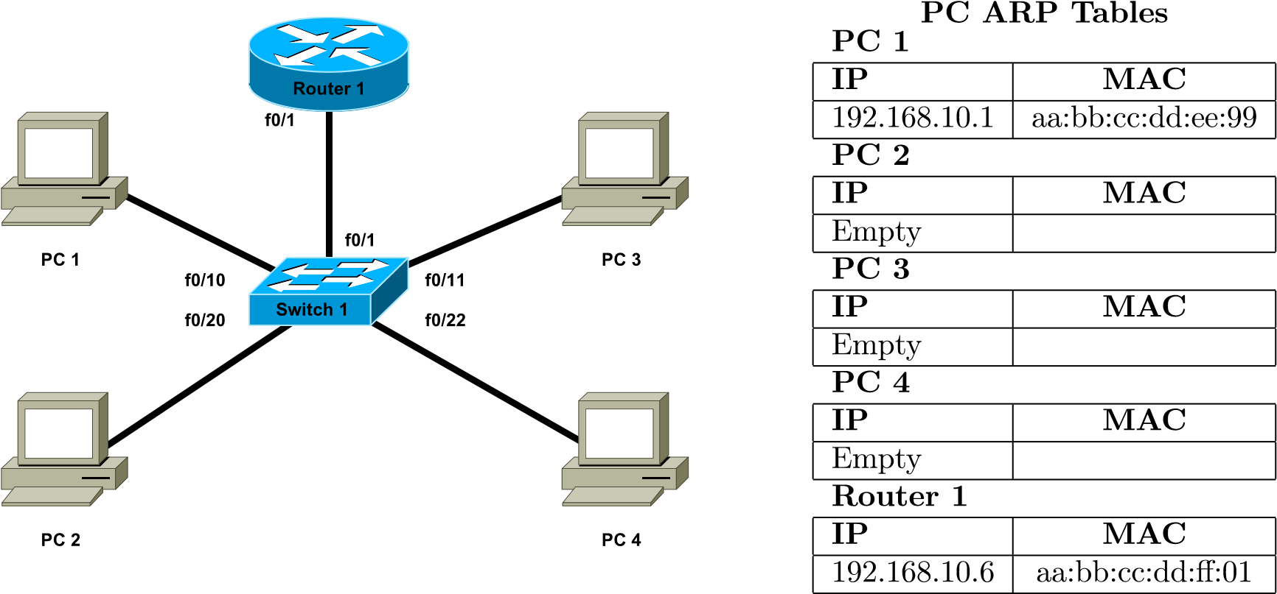

Interface Configuration Details

|  |  |  |  |  |
| --- | --- | --- | --- | --- |
| Device | Interface | VLAN | MAC | IP |
| Router 1 | f0/1.10 | 10 | aa:bb:cc:dd:ee:99 | 192.168.10.1 |
| f0/1.20 | 20 | aa:bb:cc:dd:ee:99 | 192.168.20.1 |
| f0/1.99 | 99 | aa:bb:cc:dd:ee:99 | 192.168.99.1 |
| Switch 1 | f0/1 | Trunk | – | – |
| f0/10 | 10 | – | – |
| f0/11 | 10 | – | – |
| f0/20 | 20 | – | – |
| f0/22 | 20 | – | – |
| vlan99 | 99 | aa:bb:cc:dd:00:99 | 192.168.99.5 |
| PC 1 | – | – | aa:bb:cc:dd:ff:01 | 192.168.10.6 |
| PC 2 | – | – | aa:bb:cc:dd:ff:02 | 192.168.20.7 |
| PC 3 | – | – | aa:bb:cc:dd:ff:03 | 192.168.10.8 |
| PC 4 | – | – | aa:bb:cc:dd:ff:04 | 192.168.20.9 |

|  |  |
| --- | --- |
| MAC | Port |
| aa:bb:cc:dd:ee:99 | f0/1 |
| aa:bb:cc:dd:ff:01 | f0/10 |

Switch 1 MAC Table

a) When a packet from PC1 to PC4 traverses the trunk link from Switch 1 to

Router 1, fill in the following information as seen in the packet headers

|  |  |  |
| --- | --- | --- |
|  | Source | Destination |
| MAC | **aa:bb:cc:dd:ff:01** | **aa:bb:cc:dd:ee:99** |
| IP | **192.168.10.6** | **192.168.10.1** |

(2 marks)

b) Nominate one advantage and one disadvantage of a layered network protocol architecture?

* **Advantage:**

1. Assist in protocol Design

2. Common Standard Language

* **Disadvantage:**

1. Layers create additional overhead

2. Redundancy

(2 marks)

(4 marks)

Q6 This question relates to the Spanning Tree Protocol

a) How is it possible to configure Cisco Switches such that a different switch becomes the root bridge for each VLAN?

**Ans.**

This is done by cisco per vlan spanning tree (PVST). In PVSTs, each vlan can have different switch as their root bridge. We can configure it using this command

#spanning-tree vlan X root primary.

(2 marks)

(2 marks)

Q7 This question refers to aspects of the design of Switched networks

1. At which layer(s) in a Hierarchical network (*Core, Distribution or Access*) are the following switch features most important (*you may tick more than one layer*)

|  |  |  |  |
| --- | --- | --- | --- |
| Switch Feature | Core | Distribution | Access |
| Power over Ethernet |  |  | ✓✓✓ |

(1*/*2 mark)

1. Describe briefly what the term Converged Network means?

**Ans.**

Using a properly designed hierarchical network and implementing QoS policies that can prioritize the audio and video, means they can be converged onto the data network with little to no impact on quality of service.

(1 mark)

(11*/*2 marks)

Q8 This question is about Ethernet Switching and VLANs

a) Nominate one advantage and one disadvantage to using trunking instead of Access Ports when connecting a Switch to another Switch or Router?

## i. Advantage:

Trunks allow a single connection to carry traffic of multiple VLANs.

(1 mark)

## ii. Disadvantage:

Inefficient to connect switches using Access Ports –

need one connection for each VLAN.

(1 mark)

b) Briefly explain how each of the following benefits are realised through the use of

VLANs

## **i. Cost Reduction:**

A VLAN is a logical partition of a Layer 2 network. VLANs effectively allow us to divide your physical switch into a number of virtual switches.

VLANs are cost-effective, because on workstations VLANs communicate with one another through VLAN switches and don't require routers unless they are sending data outside the VLAN

(2 marks)

(4 marks)

Q9 Consider a wireless network

a) What purpose does the SSID serve in a Wireless network?

**Ans.**

SSID is a Unique identifier that client devices use to distinguish between wireless networks. Several access points on a network can share an SSID.

(1 mark)

(1 marks)

# End of Assessment

## Student Marks – Staff Use Only

|  |  |  |  |  |  |  |  |  |  |  |
| --- | --- | --- | --- | --- | --- | --- | --- | --- | --- | --- |
| Question: | 1 | 2 | 3 | 4 | 5 | 6 | 7 | 8 | 9 | Total |
| Points: | 3 | 6 | 0 | 5 | 4 | 2 | 11*/*2 | 4 | 1 | 261*/*2 |
| Score: |  |  |  |  |  |  |  |  |  |  |